**Snow White’s Dwarves**

**Proposal for Software Engineering for Academic Research (SEAR)**

**Table of Contents**

­­Vision 3

Scope 3

Proposed Schedule 4

System Overview 4

Organization Information 5

Resumes

Austin Cole 6

Jeremy Tom 7

Amit Dahal 8-9

ChunYue Leung 10

Gerardo Ocon 11

Ren Denner 12-13

Chris West (Liaison) 14

**Vision:**

For the office administrator and clerk who need to post Faculty Information Cards for the academic staffs each semester, the Faculty Information Cards Generating System is a Database System that provide an easy way to print the card. The system will store the basic information of the academic staffs and their teaching schedules. Unlike the current system which the clerk has to create the card one by one manually, our product will generate all the cards in one operation or printing an individual card on request.

**Introduction:**In Sacramento State, every semester someone has to manually search and create a schedule (that contains info such as class time, office hours, and contact info) for each professor. Needless to say, that is a daunting and time consuming task as a person needs to search classes taught by one professor and add all that information together. This process becomes time consuming as a person needs to repeat this process for all the professors in the entire college.

**Business Opportunity:**

SEAR, Software Engineering for Academic Research, has funded us to plan and build a system to make the process of generating class schedule for each professor that is simple to use and extremely efficient.

**Scope:**

The software will let an authorized personnel input various information (office hours, contact info, and classes they teach) for all professors. Based on the input provided by authorized personnel, the system will create individual schedules for all the professors.

**Requirements:**

1. An admin should have access to make changes (Add/ Delete or modify) to the information on the database. They should have access to add a professor, delete a professor, change an existing professors’ office hours, change contact information, and change professor’s class schedule.
2. A helper for admin can only have access to make changes to office hours and viewing the schedule.
3. Everyone else should only have access to see the schedule. They can’t have access to change information.
4. With push of a button, the admin should be able to print schedule for all professors.
5. In addition to the last requirement, there also should be a way to print schedule for an individual professor.

**Constraint:**

1). Many of our team members are not experts in languages that help build the system. For instance, our team members are beginners at languages like HTML, SQL, and PHP which are all essential to build the system.

**Proposed Schedule:**

1. Feb. 26 – March 16, Team members will have enough exposure to HTML, SQL, and PHP to build the system.
2. March 28 – April 6, we will be able to get website (User Interface) that lets an admin add/remove data and make changes to them.
3. April 6 – April 13, add the searching feature for one professor (so we can print individual cards later).
4. April 13 – April 20, Helper for admin will only have access to modify office hours for professors.
5. April 20 – April 27, Be able to print schedule for all professors.
6. April 20- April 27, Be able to print schedule for individual professor.

**System Design**

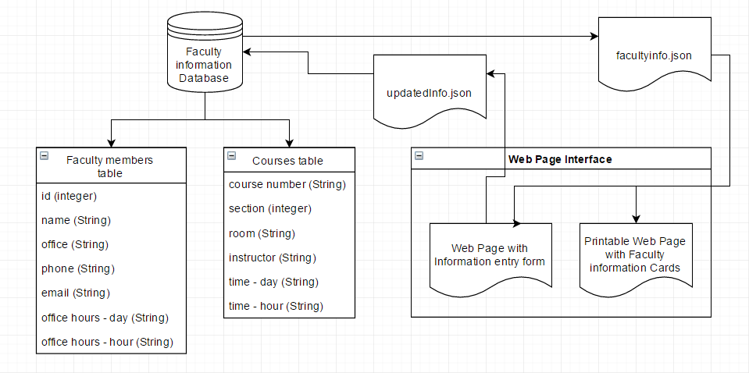

Diagram updated 2/26/2017 3:49 PM

**Snow White’s Dwarves Team Members:**

* Austin Cole
* Jeremy Tom
* Amit Dahal
* ChunYue Leung
* Gerardo Ocon
* Ren Denner
* Chris West (Liason)

Austin Cole

# Contact Information-

Phone: (916) 899-8024

E-mail: acole270@yahoo.com

# Skills-

Public Speaking/ Presentations

Working with other people

Proficient writer

Coding in C/ C++

Basic knowledge of assembly language programming

# Experience-

American River College:

SPEECH 331: Group Discussion

ENGWR 302: Advanced Composition and Critical Thinking

CISP 400: Object Oriented Programming

Five computer science classes total taken at ARC.

CISP 310: Assembly Language Programming

CSUS:

Two more computer science classes taken and passed.

**Amit Dahal**

**(530)-405-6118**

Dahalamit4@gmail.com

I am currently a student at California State University Sacramento and pursuing to major in Computer Science. By mid May 2017, I will be done with my lower division major courses and couple of my upper division major courses. I am pursuing to major in Computer Science as I love being challenged and solving those challenges.

**Skills:**

**Being able to code in C++:**

+ Object-Oriented Programming

**Being able to code in Java:**

+ Object- Oriented programming

+ currently learning Data Structures

**Multilingual:** Fluent in English, Nepali and conversant in Hindi.

**Interpersonal/Employability:**

1). Detail Oriented

2). Quick learner

3). I work well with others

**Education:**

Sacramento State University, 2016 – present (cumulative GPA 3.3, Deans List)

American River College, 2015 - 2016

Sacramento City College, 2013 – 2015

Pioneer High School 2009-2013

**Work Experience:**

# Home Depot 2015 -2016 (5 months)

* Helped customers with needs whether it be to return, buy or navigate.
* Learned to satisfy unhappy customers.
* Learned to coordinate efficiently with other cashiers.

# Kathmandu Kitchen 2013-2013 (6 months)

• Being Busser and waiter, I have experience with customer skills and making them feel welcomed.

# Tutoring in High School (2012-2013) (1 year)

* Helping other students when they were struggling in particular subjects
* Helping coordinate a group of students in tutoring

Name:

Chun Yue LEUNG

Contact:

Tel: 916-798 5155 Email: aryue1945@gmail.com

Skills set:

Basic Data Analysis on Excel Basic Microsoft Office Experience:

Simple data analytic works and office routines

Gerardo Ocon

Phone number: 2098185193

Email: gao_2213@yahoo.com

218683505

CSC 131

# Skills

* Programming languages: o Java, HTML, CSC, Javascript, and bash.
* Operating Systems: o Windows, MacOS, Linux, IOS, and Android.
* Applications o Photoshop, Word, Excel, PowerPoint.

# Experience

* Modesto Junior College; 2 years  Sacramento State; 1 year  W3schools.com; present
* Freecodecamp.com; present

**Ren M. Jardine**

805-868-4160 | dennerren@gmail.com

Objective: To obtain a working knowledge and experience through an internship in my field

# Education

* Dean's Honor Roll student in the Master's program in Computer Science at California State University, Sacramento, expected graduation Spring of 2019
* Courses: Programming Concepts and Methodology II, Discrete Structures for Computer Science, Introduction to Computer Architecture, Introduction to Systems Programming in

UNIX, Data Structures and Algorithm Analysis, Computer Software Engineering

* Member of Association for Computing Machinery

# Technical Skills

* Well versed in Java
* Comfortable in Assembly Language
* Comfortable in C
* General working knowledge of HTML
* Basic working knowledge of GUI
* Familiar with Windows, Linux and Unix operating systems
* Basic understanding of MySQL and databases
* Very cooperative in a team setting
* Fully commits to every project assigned
* Works well through stressful situations

# Experience

* Using Java since high school, beginning in August of 2013, for various projects with arrays, linked lists, queues and decks including a simple GUI calculator
* Learning Assembly since August of 2016 culminating with a trick gambling game project
* Began learning C, HTML and navigating Linux systems since December of 2016, reinforced in class projects
* Worked as a Stage Manager, managing the stage and working for the director, or Assistant Stage Manager, often filling in for the Stage Manger when necessary, on ten community and college theater productions beginning August of 2013
* Worked as a Big Sister for Big Brothers, Big Sisters of America for four years beginning August of 2011 mentoring elementary aged children every Friday after school

# Abilities and Activities

* Fluent in French
* Can read Spanish
* Simple knowledge of Italian

Chris West

Skills

Programming: Java, C, HTML, Javascript, CSS, Python, Assembly for ARM, Android programming

Computer Repair: Hardware and software repair

Utilities: Office Suite, Adobe CC(Dreamweaver, Photoshop and Illustrator) Operating Systems: Windows, Mac OS, Linux

Experiences

Courses at Sierra College provide most programming language experience

Web development for friend’s photography portfolio